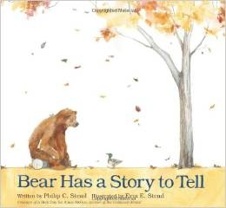
Bear Has a Story to Tell
by
Philip C. Stead and Erin E. Stead

As you look at Practickle’s past reading selections, it is obvious that we love the friendly stories of Philip Stead and the warm illustrations of his wife, Erin. In this story, Mr. Stead uses his characters to model the meanings of loyal friendship, loving generosity, and caring patience. As you read the story, the reading guide suggests discussing Bear’s personality traits that make him such a good friend. It’s obvious that Mr. Stead feels that creating characters who illustrate the meaning of friendship is important for young children.

Bear Has a Story to Tell is a good book to read at the end of October. You will see from the illustrations that the setting is fall. This leads to discussions about the informational parts of the story. How does each animal prepare for winter? Each animal has a unique way to spend the cold months.

The Reading Comprehension Best Practice that matches this lovely story is to Have a Purpose for Reading. After studying the illustrations, think of questions you hope the text will answer. The first question that occurred to my granddaughter was, “What is the story Bear wants to tell?” Forming questions before reading and then answering the questions through direct details from the text or by forming inferences improves comprehension of the text at a higher thinking level than just recall.

Bear Has a Story to Tell won the Kirkus Review’s Best Children’s Book of 2012.

