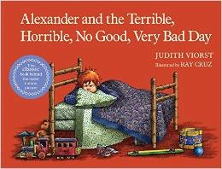
Alexander and the Terrible, Horrible, No Good, Very Bad Day

by

Judith Viorst

As you read about Alexander’s day, both your listener and you will empathize with Alexander. Many times, you’ll being saying, “Oh, no! Poor Alexander.” Or “I know how he feels.” Don’t worry. No serious problems befall Alexander. His day is full of little things that add up to make him feel bad about his day. One of the points that I like to make when I read this book to my grandson, Alexander, is that all of these little things don’t have to upset him. It’s all about attitude. As you will see in the Third Reading, a great discussion can be had about looking for the positive in tough situations. Alexander may not be able to change the situation, but he can change his attitude. It’s human to have days like this, as we all know. However, it’s your attitude that can change the day around.

The Reading Comprehension Best Practice that fits well with this story is Making Predictions. During the First Reading, you will have fun looking at the details in the pen and ink illustrations, and predicting what the text will say about what causes the looks on Alexander’s face. When you read the text in the Second Reading, you’ll use Alexander’s own words to validate your predictions. You will be reinforcing that good readers use the evidence found in the actual text to confirm or alter their predictions.

Judith Viorst’s picture book was honored as an American Library Association Notable Book in 1972. Along with other awards, it has been made into a musical at the Kennedy Center. Disney Studios is making a movie about Alexander’s day staring Steve Carell and Jennifer Garner as his parents.

You’ll have a wonderful time reading about Alexander’s terrible, horrible, no good, very bad day.

